Baggett Elementary School
Family Engagement Plan
2025-2026

948 Williams Lake Road
Powder Springs, Ga 30127
678-460-1570
www.paulding.k12.ga.us
Principal: Dr. Alisha Queen
Revision Date: 9/3/2025

Baggett Elementary Parent and Family Engagement Plan
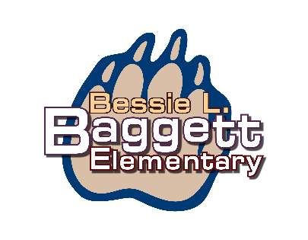
All In- Every Day, Every Play
Baggett Parent and Family Engagement Plan is an outline of what we will provide for parents and guardians, and how we will provide opportunities to work together, to strengthen the academic success of students in our school. This plan will be developed annually with input from parents and school staff to meet the academic needs of students. Baggett Elementary will support parent engagement and the plan outlines how parents can participate in activities/events that promote student learning at home.

Our Parent and Family Engagement Plan will be updated every year. In early spring, a survey will be made available to parents and may be taken online or on a paper copy that is sent home to parents of our students. It is advertised through bulletins, phone calls, and in parent meetings. The survey asks for feedback on the components of the current plan and parent involvement opportunities that took place during the school year and invites suggestions and input in the development of the updated Parent and Family Engagement Plan. Participation from parents will be sought through responses on feedback forms provided at all parent involvement meetings and activities, the availability of a suggestion box, and meetings planned specifically for developing the plan together. If the plan is not satisfactory to parents, comments will be submitted to the district for review.
Baggett Elementary is a Title I School

Title I is a federally funded program for schools. The funds are used for educational services for children to provide additional support to ensure academic success. The focus of the Title I program is on helping students meet high standards. At Baggett Elementary, our Title I program provides the following:
- Teachers who work with students who can benefit from additional support
- Learning resources for students
- Professional learning resources for teachers
- Resources and activities for parents to access and participate as they support their child academically

Once the plan is created, it is presented to parents, and the school staff (in parent engagement meetings, through the school website, and accessibility to paper copies in the school) for final agreement; it is then introduced as the Parent and Family Engagement Plan for the current school year at the Annual Title I Parent Involvement Meeting which takes place in early fall.

Baggett’s Family and Parent Engagement Plan will be distributed to parents/guardians of students in our school and is available on our school website and in our Parent Resource Center. It is written in a language that parents can understand, and translation is available upon request. We strive to make continual progress in working with our parents, and welcome any feedback and suggestions on meeting times, formats, and topics at all times throughout the school year.

Baggett Elementary Parent and Family Engagement Plan and Activities

Paulding County District
2025-2026 Goals

- By May 2026, enhance the quality and effectiveness of professional learning initiatives to empower teachers in positively transforming their instructional practices, thereby directly impacting student achievement.
- By May 2026, cultivate meaningful collaborative opportunities that foster strong relationships and active engagement between District staff, families, and communities, resulting in a positive impact on student achievement.
- Increase student performance in all core content areas by 3% annually as measured by achievement data

Baggett Elementary will host the following events to build the capacity for strong parental involvement in effort to support a partnership among the school, parents, and the community as we work together to improve student academic achievement. Meetings and activities will be provided at a variety of times and in different formats to help accommodate parent/guardian schedules. Families of students are invited to parent meetings and family events in a variety of ways including flyers, and on our school website.

July 29, 2025 - Open House - Teacher- Meet and Greet
Meet your child’s teacher and our friendly and helpful school staff and receive pertinent information from your child’s teacher. Parents are also invited to visit the Parent Resource Center, Media Center and classrooms to meet their teachers and sign up for texting communication through Dojo.
to discuss schoolwide programs, grade level goals, curriculum, assessments, procedures,
Topics for Meetings and Website Information: (offered at a variety of times and days)
- Development/Revision opportunities for Parent and Family Engagement Plan, Family -School Compact, Title I Schoolwide Improvement Plan (SW Plan), Staff Capacity, and Parent Engagement Budget (Spring of each year)
- Individual Student Assessment results and interpretation of those results (next steps)
Baggett Elementary School Improvement
2025-2026 Goals

By the end of the 2025-2026 school year (SY26), we will increase the percentage of 3rd, 4th, and 5th grade students scoring proficient and above in:
-English Language Arts (ELA) on the Georgia Milestones Assessment (GMAS) by 10% from 27%(SY25) to 37%(SY26)
-Math on the GMAS by 10% from 32% (SY25) to 42% (SY26).

By the end of the 2025-2026 school year (SY26), we will increase the percentage of 3rd, 4th, and 5th grade students with disabilities (SWD) scoring proficient and above in:
-English Language Arts (ELA) on the Georgia Milestones Assessment (GMAS) by 10% from 2%(SY25) to 12%(SY26)
-Math on the GMAS by 10% from 5% (SY25) to 15%(SY26)

- Description of school, local, & state curriculum and assessments (Georgia Standards of Excellence, individual checkpoints, PCSD Universal Screener, and Georgia Milestones)
- Supporting parents with use of technology Ongoing
- Kindergarten and Middle School transition information January-May
- Ways to monitor your child’s progress Ongoing
- Other topics based upon parent feedback or request Ongoing
October 2025 - Annual Title I Meeting
Parents of students are invited to learn the details of our Title I program, including our Parent and Family Engagement Plan, the School District Parent Engagement Plan the School Improvement Plan, the Family-School Compacts, the Title I parent engagement budget, and parents’ rights under Title I, Part A. Invitations will be sent home, posted in the school’s newsletters, and on the school’s website.
Parent-Teacher and Student Conferences (October 13-14, 2025, & March 16-17, 2026)
Meet with your child’s teacher to discuss your child’s progress and school experience, ask questions, and learn how you can be involved in supporting your child’s learning. Parents will be invited to visit the Parent Resource Center throughout the week of conferences to receive support and resources. Compacts will be discussed and distributed at this time.
May 2025 - Spring Input and Transition meeting
The Spring planning meeting will provide parents the opportunity to give input in the development of the Parent Engagement Budget, Compacts, Budget, Staff Capacity, and Parent and Family Engagement Plans (school and district) and the Schoolwide Improvement Plan for the upcoming school year.
Parents will also receive guidance and resources on how to support their student’s transition to the next grade level.

Baggett Elementary Parent Involvement
School-Parent Compacts
Baggett’s Parent Engagement Plan includes a Compact, which is developed jointly by staff, parents/guardians, and students. The Compact is an agreement that explains how parents/guardians, teachers, and students will work together, to make sure that every student is supported in reaching academic success. All parents of students at Baggett Elementary School are invited to review the Compact and provide feedback and input every year. Revisions are made, based on input from parents, students and teachers. They are shared in October at Parent-Teacher Conference time and serve as a reminder of our commitment to action in supporting every student at Baggett Elementary. All parents keep a copy of the compact. The Compact will be utilized throughout the year at parent teacher conferences in October and March, parent meetings, workshops and family nights. It will also be available in our Parent Resource Room, parent display in the school office and on Baggett’s website under the Title I tab.
Baggett Elementary will take the following measures to promote and support parents as an important foundation of the school in order to strengthen the school and reach our school goals. We will –

  - Provide information related to school meetings and programs in a language that parents can understand (as requested); provide information related to engagement opportunities and events through the school website, phone calls, and monthly parent newsletters.
  - Provide professional development with staff and parents during after school meetings, grade level planning time, and Local School Council meetings that focus on our school improvement parent involvement goals, parent involvement practices, including conducting meaningful parent conferences, the use of Parent Resource Center materials, and effective communication strategies including the use of newsletters.
  - Coordinate services for students experiencing homelessness or transitions to or from neglected or
delinquent facilities.
  - Establish a partnership with local Pre-K programs to provide school information and transitional support for parents to more fully participate in the education of their child. Partnerships are established through visits to neighboring Pre-K and Daycares as well as hosting tours and visits when possible.
  - Provide school’s academic standards, assessments, and ways to monitor their child’s progress through the school website, newsletters, and during parent meetings and family night events.
  - Continue to inform in a variety of ways that provide families and community stakeholders with information about school events and activities, using email, newsletters, flyers, invitations school websites and
texting through Dojo.
  - Consistently use parent feedback to determine professional learning needs of our staff as it pertains to parent engagement. Feedback in the form of checklists, a ticket out the door and general meeting surveys are collected after every parent event and used to help plan future events and parent opportunities, in addition to the annual parent Title I survey.
Baggett’s Commitment
At Baggett Elementary, we support our parents/guardians in attending the parental activities included in this plan. We make every effort to communicate the details of events in several ways, including newsletters, bulletins, phone calls, Dojo texting and school website postings. Please call or email us if you require further information or assistance in any way in order to participate in our activities.
Please contact Julie Holmes, Title I Parent Engagement Coach with any request for support.
678-460-1570
jholmes@paulding.k12.ga.us
  - Supply parents with the necessary materials at conferences, meetings, workshops, and family
nights, to help parents work with their child to improve achievement. Resources and strategies to enhance student achievement, math and reading activities from the Parent Resource Center to help with a specific skill, and directions and websites for web-based programs to use as resources at home. We will also include information on the Georgia Milestones and how to interpret those scores.
  - Communicate with local stakeholders to increase participation and awareness of the school parental involvement plan and activities through weekly class newsletters, Title I and school newsletters, Baggett’s website, Dojo, email, flyers, and invitations.
  - Provide parents information on ways to enhance their education upon request through resources in the Parent Resource Center and parent meetings, workshops and family nights, and connection to community resources.
  - Solicit feedback and provide parent support for additional parental involvement activities after every parent event through questionnaires, checklists, and surveys.

All parents/guardians of students attending Baggett Elementary are invited to participate in planned events and activities.
Language translation of Title I materials and documents shared with parents/guardians is available upon request.

Parent Involvement Standards
Baggett Elementary and our parents have adopted the National PTA Standards for Family-School Partnerships as the school’s model in engaging parents, students, and the community. These standards are –
- Open House Welcoming All Families
- Communicating Effectively
- Supporting Student Success
- Speaking Up for Every Child
- Sharing Power
- Collaborating with Community
Parent Involvement is Important!
At Baggett Elementary we value the contributions of our parents and understand that building connections between home and school are essential to student academic achievement.

Regardless of family income or background, students with involved parents are more likely to:

- Earn higher grades and test scores, and enroll in higher-level programs
- Be promoted and pass their classes
- Attend school regularly
- Have better social skills, show improved behavior, and adapt well to school
- Graduate and go on to further education

School staff is available for meetings, and appointments may be arranged by contacting Baggett Elementary at 678-460-1570.
Baggett Elementary Parent Resource Center Location - Baggett Media Center
Hours - 7:30 a.m. - 3:30 p.m. Open Daily

Baggett Elementary is pleased to offer a Parent Resource Center. The Parent Resource Center offers educational games, informational resources, and a variety of materials for parents to borrow, for free, as they work with their child in supporting academic success. Throughout the year, new items and informational resources are added. New additions to the center are advertised through flyers, phone calls and articles in the school newsletter.
Resources will be sent home by request. You may request items to be sent home by completing the survey on the Baggett website, by contacting the Title I Parent Engagement Coach, Julie Holmes, or your child’s homeroom teacher.
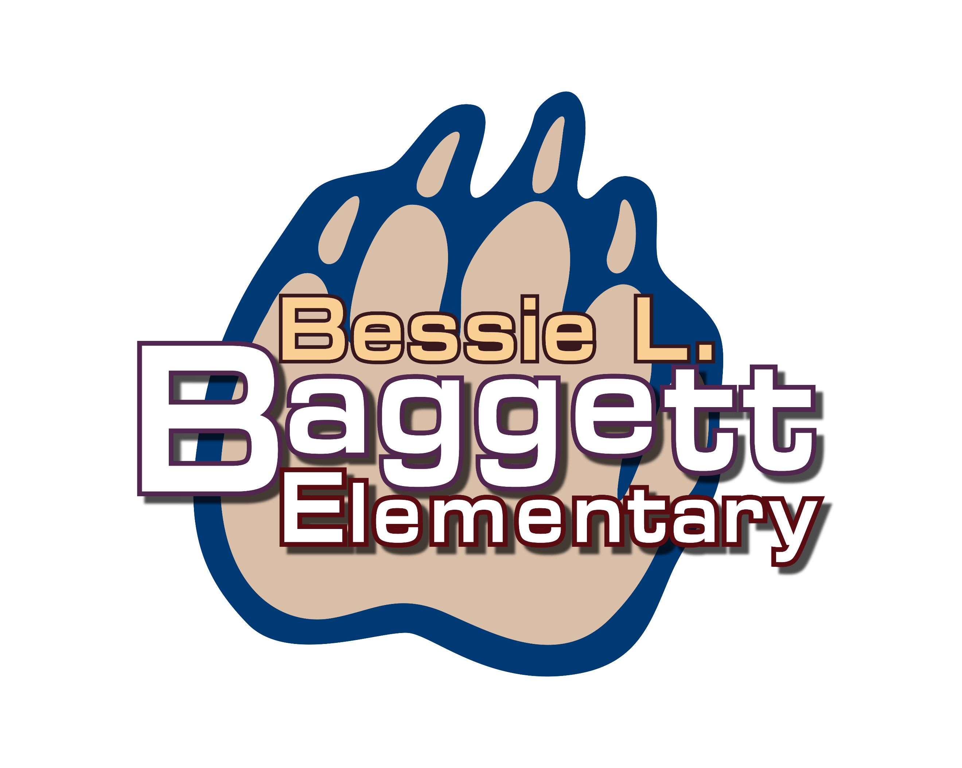
Title I Team
Julie Holmes- Parent Engagement Coach
Annette Watts- Instructional Lead Coach
Courtney Romain- Title I Teacher
Kellie Grant- Title I Teacher
Alisha Queen- Principal
Thomas Beames- Assistant Principal
Melissa Maycumber- Evaluation and Assessment Coordinator

If this plan is not satisfactory to the parent and students at Baggett Elementary, the school will submit any parent comments with this plan to Dr. Tameka Walker, Paulding County School District, Director of Federal Programs: Paulding County Board of Education
3236 Atlanta Highway, Dallas, Ga 30132

